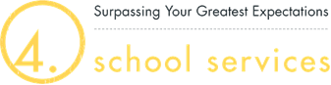

I, ____________________________, hereby provide consent to Chisago Lakes Bus Service to conduct a limited query of the FMCSA Commercial Driver’s License Drug and Alcohol Clearinghouse (Clearinghouse) to determine whether drug or alcohol violation information about me exists in the Clearinghouse.
This consent shall remain in effect throughout the term of my employment with Chisago Lakes Bus Service.
I understand that if the limited query conducted by Chisago Lakes Bus Service indicates that drug or alcohol violation information about me exists in the Clearinghouse, FMCSA will not disclose that information to Chisago Lakes Bus Service without first obtaining additional consent from me.
I further understand that if I refuse to provide consent for Chisago Lakes Bus Service to conduct a limited, or a full query, of the Clearinghouse, Chisago Lakes Bus Service must prohibit me from performing safety-sensitive functions, including driving a commercial motor vehicle, as required by FMCSA’s drug and alcohol regulations.

__________________________ ______________________________________________
Date Printed Name

______________________________________________
Signature

