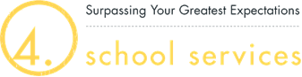

I, ____________________________, hereby provide consent to 4.0 Metro Inc. to conduct a limited query of the FMCSA Commercial Driver’s License Drug and Alcohol Clearinghouse (Clearinghouse) to determine whether drug or alcohol violation information about me exists in the Clearinghouse.
This consent shall remain in effect throughout the term of my employment with 4.0 Metro Inc.
I understand that if the limited query conducted by 4.0 Metro Inc. indicates that drug or alcohol violation information about me exists in the Clearinghouse, FMCSA will not disclose that information to 4.0 Metro Inc. without first obtaining additional consent from me.
I further understand that if I refuse to provide consent for 4.0 Metro Inc. to conduct a limited, or a full query, of the Clearinghouse, 4.0 Metro Inc. must prohibit me from performing safety-sensitive functions, including driving a commercial motor vehicle, as required by FMCSA’s drug and alcohol regulations.

__________________________ ______________________________________________
Date Printed Name

______________________________________________
Signature

